**Year 12 Human Biology**

Mark:_________/35

**Extended Response: Homeostasis**

**Question 1)**

The homeostatic regulation of **water** and **oxygen** concentrations of the blood are both examples of negative feedback systems.

1. Discuss the differences between the involuntary homeostatic mechanisms at each stage of these feedback loops. In your answer assume that water concentration of the blood is high and oxygen concentration of the blood is very low. (23 marks)

|  |  |  |
| --- | --- | --- |
|  | Water Level | Oxygen Concentration |
| Stimulus | Low osmotic pressure (1) | Oxygen Concentration (1) in the blood is low |
| Receptors | Osmoreceptors (1)  In hypothalamus (1) | Chemoreceptors (1)  In aortic and carotid bodies and medulla oblongata (1) |
| Modulator | Posterior pituitary gland (1) Stops the release of ADH (1) | Medulla oblongata (1)  Respiratory centre (1) |
| Message Type | Hormonal (1) | Neural (1)  intercostal nerve and phrenic nerve (1)  nerve impulses sent via sympathetic nerves (1) |
| Effector | Nephron tubules (1) of the  kidney (1) | Intercostal muscles (1)  Diaphragm (1)  OR respiratory muscles (1) |
| Response | DCT and CD become less permeable to water (1)  Less water is reabsorbed (1)  from the kidney into the blood stream (1)  Larger volume of dilute urine is produced (1) | Diaphragm muscles and intercostal muscles / respiratory muscles contract deeper and more often (1)  Increased breathing rate (1) |
| Feedback | Negative – water content in blood is opposite to the original stimulus (1) | Negative – oxygen content in blood is opposite to the original stimulus (1) |

**MAX 10 marks if the differences between feedback loops are not explicitly discussed**

1. Discuss the reasons why we have voluntary control over breathing.

(2 marks)

• Allows us to speak

• Protective device – stop irritating gases or water from entering respiratory system

• Allows us to swim

Any two from above

**Question 2)**

The inability to maintain optimal blood glucose levels results in the condition called diabetes mellitus. This condition occurs in two different forms known as Type 1 and Type 2.

In what ways are these **two** forms of diabetes mellitus similar and how do they differ?

(10 marks)

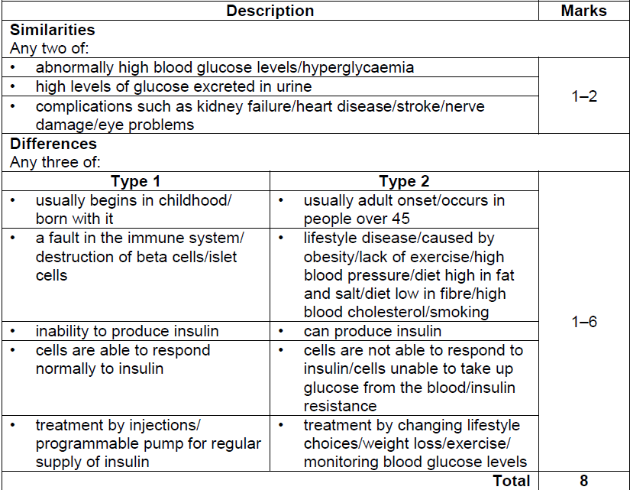

10

1 - 8